

SIMATS ENGINEERING

Saveetha Institute of Medical and Technical Sciences
Chennai- 602105

Student Name: A. YUVAN CHARAN Reg. No:192424383
Course Code: DSA0216 Slot: B
Course Name: COMPUTER VISION WITH OPEN CV
Course Faculty: DR. SENTHILVADIVU S & DR. KUMARAGURUBARAN T
Project Title:
Vision-Based Early Screening and Risk Classification of Parkinson’s Disease Using Hand Tremor Analysis
Module Photographs:
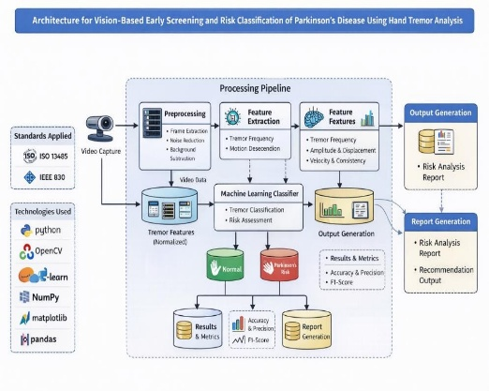
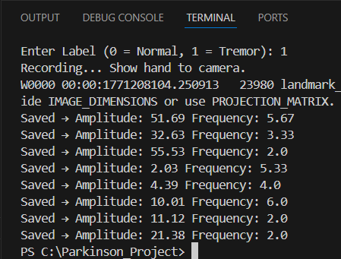

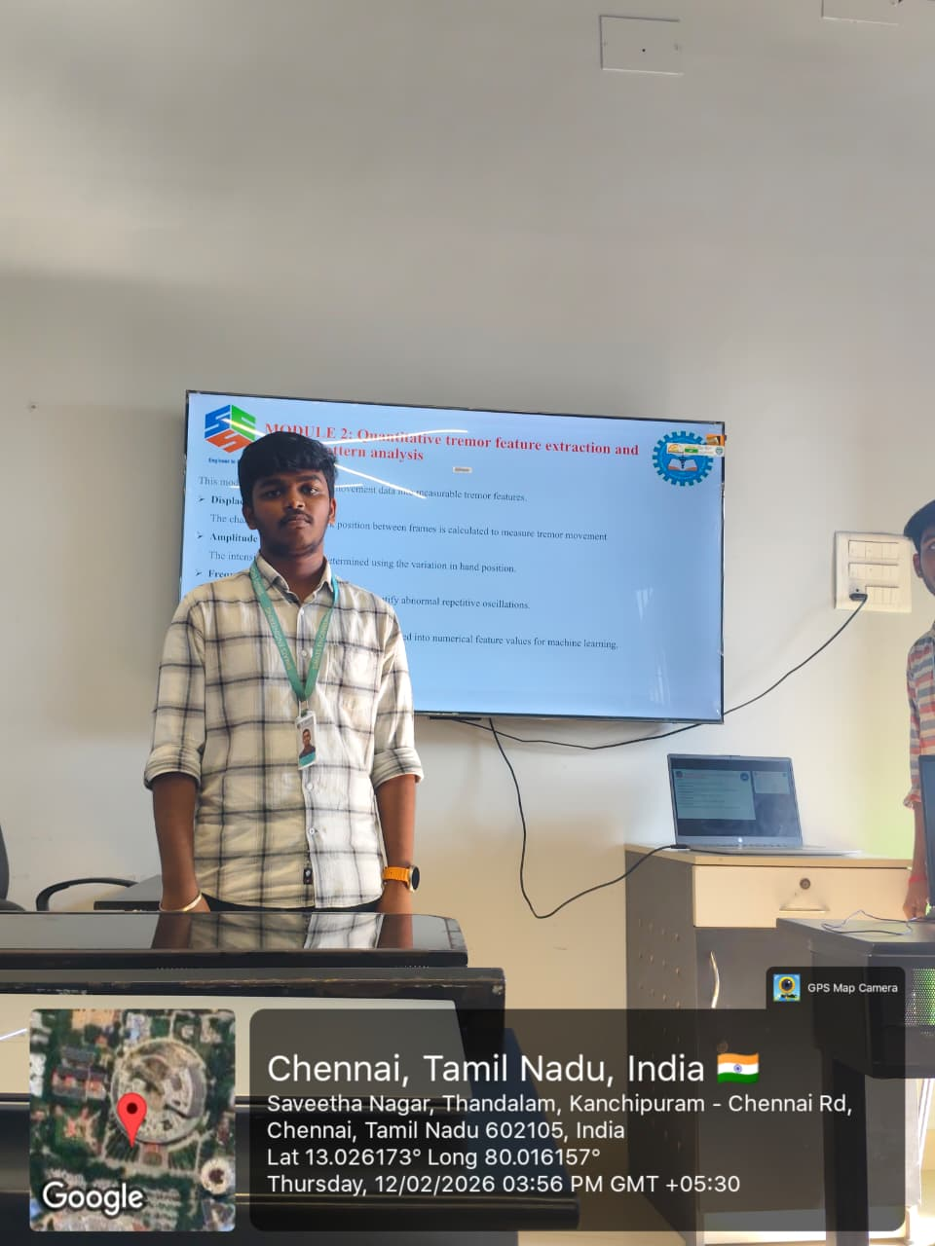
Project Description: Quantitative tremor feature extraction and motion pattern analysis
The Quantitative Tremor Feature Extraction and Motion Pattern Analysis Module functions as the project’s central analysis and feature extraction engine, transforming raw kinematic data into diagnostic insights. Its primary goal is to isolate and quantify specific tremor characteristics captured from computer vision-based hand tracking by translating spatial movements into measurable digital biomarkers. The module accepts cleaned and normalized hand movement data—including fingertip pixel coordinates, peak-to-peak amplitude values, and power spectral density—processing these inputs through rigorous quantitative signal analysis and Fast Fourier Transform (FFT) techniques. A critical deliverable of this module is the generation of multiple motion plots and analytical charts, specifically displaying real-time amplitude and frequency visualization graphs to illustrate tremor intensity and rhythmic variations over time. To ensure high-level validation and analytical assurance, the module incorporates sophisticated filtering protocols to highlight stable tremor patterns while explicitly stripping away voluntary movements and background noise. This refined processing pipeline ensures that the resulting data reflects only the involuntary pathological oscillations necessary for precise medical or technical assessment.

Student Signature Guide Signature

